**RS-MG111-N01-1-ABL**

**Multifunctional air quality transmitter**

**(Type 485)**

**User manual**

Document version：V1.0

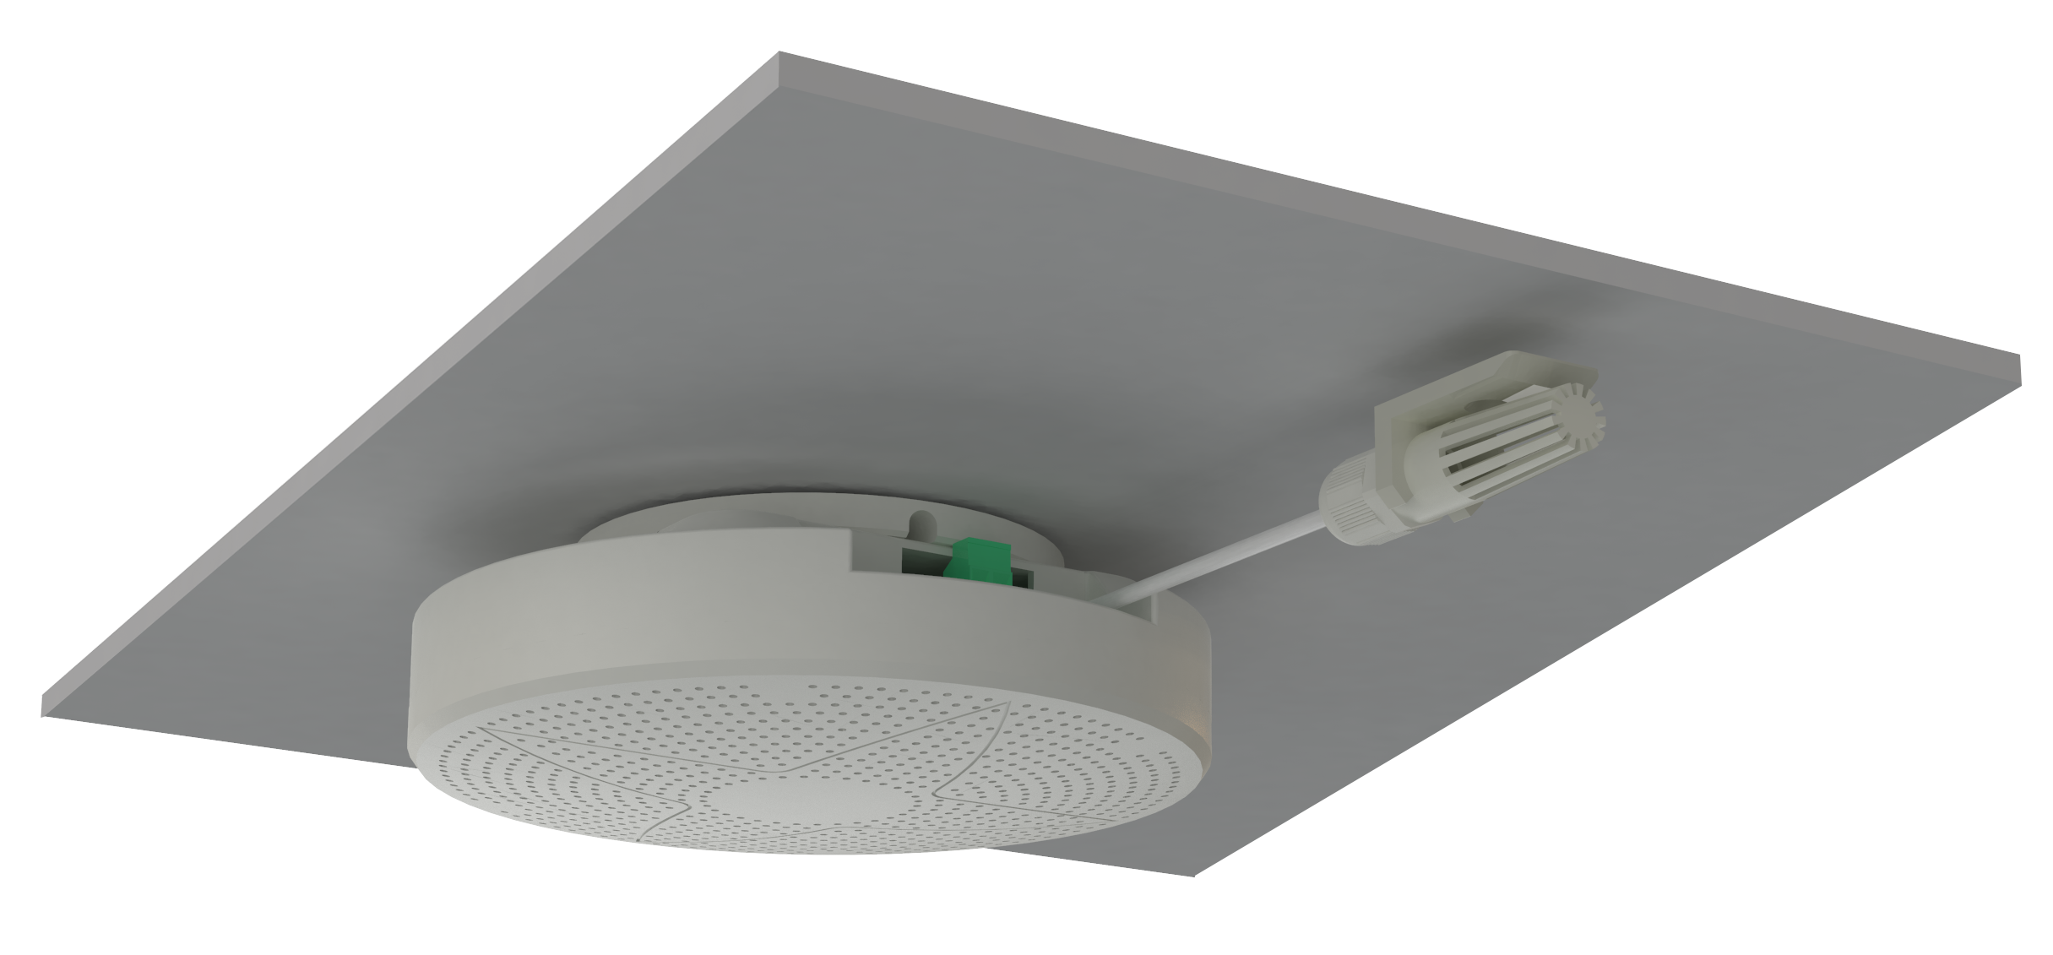

**Table of Contents**

1.Product Brief 3

1.1product description 3

1.2Features 3

1.3Technical index 3

2.product model 4

3.device installation 5

3.1Check before installation 5

3.2Equipment size 5

3.3Installation Notes 6

3.3Examples of installation methods 7

4.Interface Description 8

5.Configuration software installation and use 8

5.1Software selection 8

5.2parameter settings 8

6.letter of agreement 9

6.1Communication basic parameters 9

6.2Data frame format definition 9

6.3Register address 10

6.4Communication protocol example and explanation 11

7.Common problems and solutions 12

8.contact details 13

9.Document history 13

# 1.Product Brief

## 1.1product description

## RS-MG111-1 is an air environment comprehensive index monitor independently developed by our company for detecting PM2.5, PM10, temperature, humidity, air pressure, light, TVOC, O2, carbon dioxide (CO2), Carbon monoxide (CO), formaldehyde (CH2O) and other parameters are very powerful and basically cover various indicators that reflect air quality. The transmitter uses imported sensors and arithmetic chips, with high precision, high resolution and good stability. Widely used in building HVAC, building energy saving, smart home, schools, hospitals, airport stations and other places.

## 1.2Features

1. It integrates a variety of measurement elements into one, with powerful functions.

2. The temperature and humidity measurement unit is imported from Switzerland, and the measurement is accurate.

3. PM2.5 and PM10 are collected at the same time, range: 0-1000ug / m3, resolution 1ug / m3, unique dual-frequency data collection and automatic calibration technology, consistency can reach ± 10%.

4. The gas unit uses electrochemical and catalytic combustion sensors with excellent sensitivity and repeat ability.

5. The TVOC measuring unit adopts foreign imported high-sensitivity gas detection probes. The technology is mature, and the high-performance signal acquisition circuit is used. The signal is stable and the accuracy is high.

6. Wide range 0-120Kpa air pressure range, can be applied to various altitudes.

7. Adopt special 485 circuit, the communication is stable, and the power supply is within 10 ~ 30V wide voltage range.

1.3Technical index

|  |  |
| --- | --- |
| DC power supply (default) | DC 10-30V |
| Maximum power consumption | 0.5W (24V DC power supply) |
| Detection parameters | Temperature, humidity, PM2.5, PM10, air pressure, light, TVOC, CO2, formaldehyde, O3, CO, CH4, O2, SO2, NO2, H2, H2S, NH3 |
| working environment: | Temperature -10 ℃ -55 ℃; humidity 0 ~ 95% RH non-condensing |
| Signal output | RS485 output (standard Modbus-RTU protocol) |
| product material | ABS |
| Installation method | Wall hanging, ceiling |

|  |  |  |  |  |
| --- | --- | --- | --- | --- |
| Detection parameters | Range | Resolution | Accuracy | Preheat time |
| PM2.5 | 0~1000ug/m3 | 1ug/m3 | ±10% | ≤2min |
| PM10 | 0~1000ug/m3 |
| temperature | -40℃~+120℃ | 0.1℃ | ±3%RH |  |
| humidity | 0%RH-100%RH | 0.1%RH | ±0.5℃ |  |
| Atmospheric pressure | 0~120Kpa | 0.1Kpa | ±0.15Kpa@25℃75Kpa |  |
| Illumination | 0~200000Lux | 1Lux | ±7%(25℃) |  |
| TVOC | 0~60000ppb | 1ppb | ±8%FS±125ppb |  |
| carbon dioxide | 0~5000ppm | 1ppm | ±(40ppm+ 3%F·S) | 2min (available), 10min (maximum accuracy) |
| formaldehyde | 0~5ppm | 0.01ppm | ±5%FS | ≥5 minutes |
| ozone | 0~10ppm | 0.01ppm | ±6%FS | ≥5 minutes |
| O2 | 0~25%Vol | 0.1%Vol | ±3%FS | ≥5 minutes |
| H2S | 0~100ppm | 1ppm | ±3%FS | ≥5 minutes |
| CH4 | 0~100%LEL | 1%LEL | ±5%FS | ≥5 minutes |
| CO | 0~1000ppm | 1ppm | ±3%FS | ≥5 minutes |
| NO2 | 0~20ppm | 0.1ppm | ±3%FS | ≥5 minutes |
| SO2 | 0~20ppm | 0.1ppm | ±3%FS | ≥5 minutes |
| H2 | 0~1000ppm | 1ppm | ±3%FS | ≥5 minutes |
| NH3 | 0~100ppm | 1ppm | ±2%FS | ≥5 minutes |

## All the above specifications except those that have been specially stated are measured under the environmental conditions: temperature 20 ℃, relative humidity 50% RH, 1 atmosphere, and the gas concentration to be measured does not exceed the sensor range.

## 2.product model

RS - MG 11 1-N01 1

□Detector housing

□RS485Output

□Element combination form

□Number of elements

□Compound air quality detector

□Company code

Element type description：

|  |  |  |  |  |
| --- | --- | --- | --- | --- |
| 11 optional detection elements | Numbering |  | | Explanation |
| PM2.5 | A |  | |  |
| PM10 |
| temperature | B |  | | Air temperature and humidity |
| humidity |
| Atmospheric pressure | C |  | | 0~120Kpa |
| Illumination | D |  | | 0~200000Lux |
| TVOC | E |  | | Total volatile organic compounds |
| carbon dioxide | F |  | | CO2 range 0-5000ppm |
| formaldehyde | G | 5P | | CH2O range 0~5ppm |
| ozone | H | 10P | | O3 range 0~10ppm |
| In addition to the above detection elements, three gases can be selected from the gas selection on the right | I | O2 | 25VOL | O2 range 25VOL |
| J | H2S | 100P | H2S range 100 ppm |
| K | CH4 | 100LEL | CH4 range 100 LEL |
| L | CO | 1000P | CO range 1000 ppm |
| M | NO2 | 20P | NO2 range 20ppm |
| N | SO2 | 20P | SO2 range 20ppm |
| O | H2 | 1000P | H2 range 1000ppm |
| P | NH3 | 100P | NH3 range 100ppm |

**Selection examples：**If the selected measurement elements are PM2.5, PM10, temperature, humidity, formaldehyde, O2, CH4, CO. Then the corresponding selection is RS-MG111-N01-1-ABGIKL

# 3.device installation

## 3.1Check before installation

Equipment List:

## 1. A multi-function air quality detector

## 2. Install a card holder (optional)

## 3. Pack of mounting screws

## 4. Product certificate, warranty card

## 3.2Equipment size

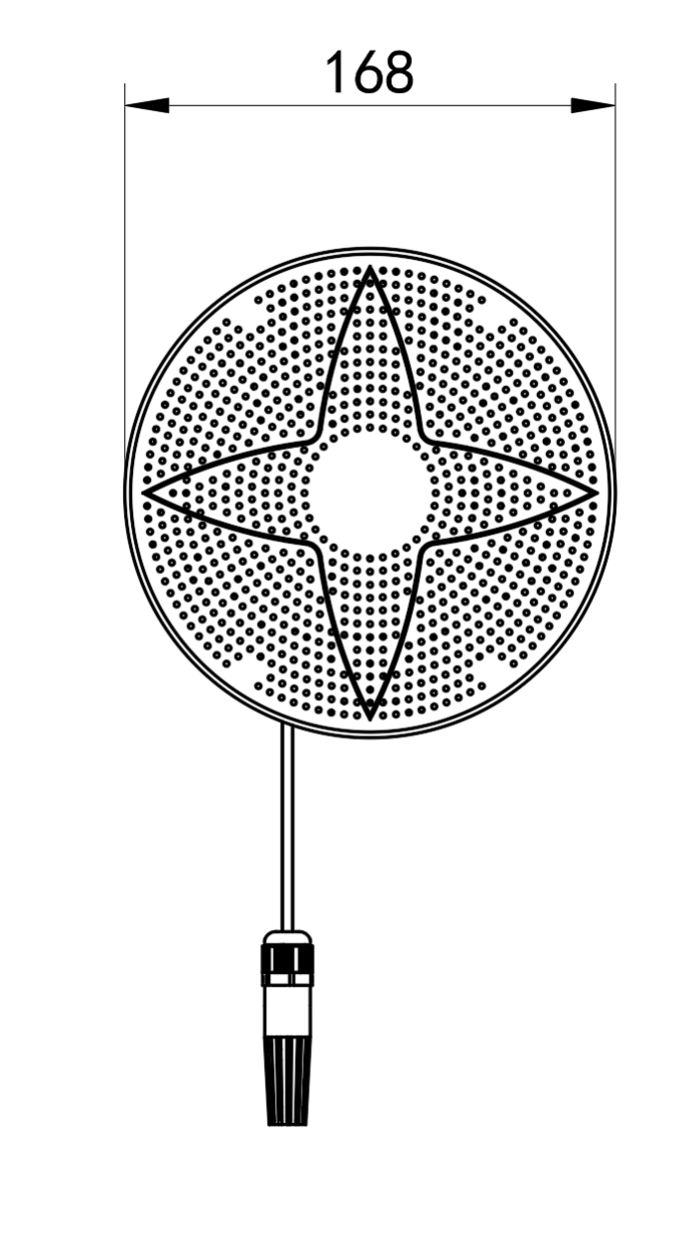

## 3.3Installation Notes

First drill holes in the wall and fix the mounting base to the wall or roof. The installation aperture and spacing are shown in the following figure:

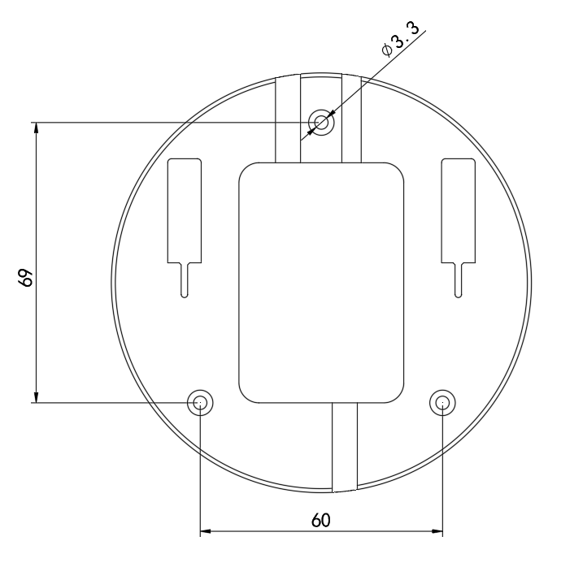

**Mounting base size (unit: mm)**

Fix the installation socket, and snap the device into the installation base, as shown in the following figure:

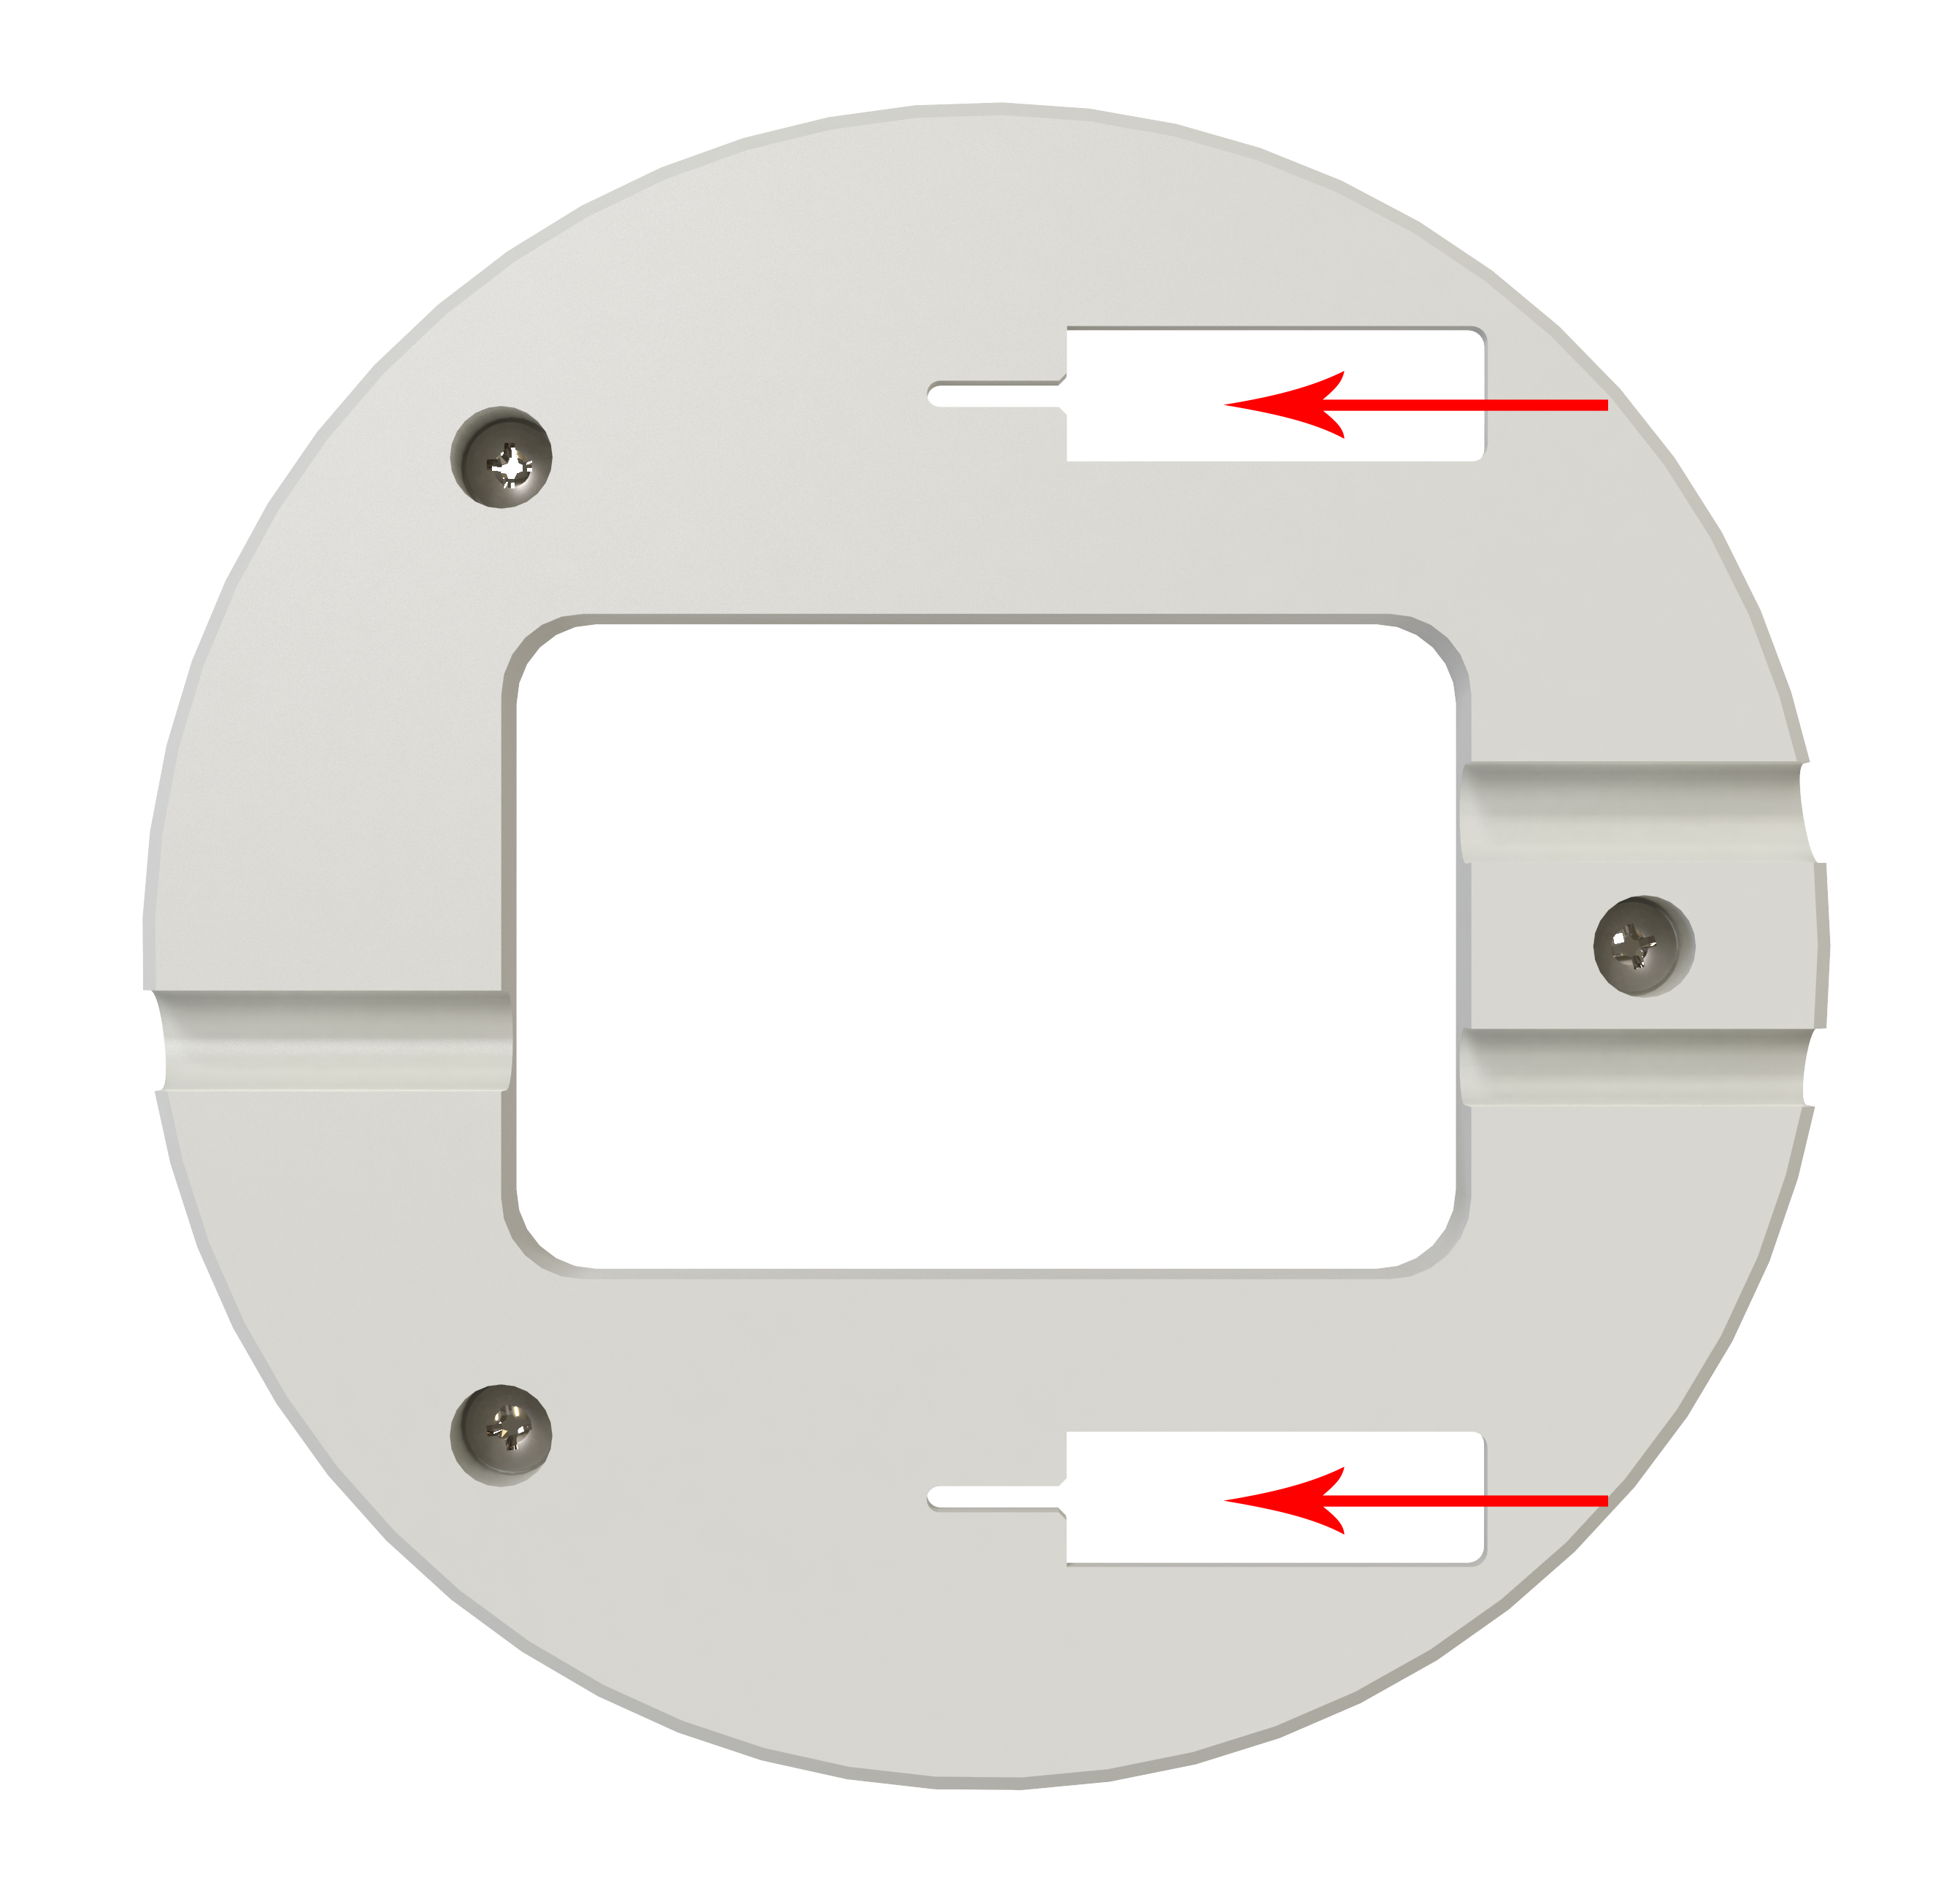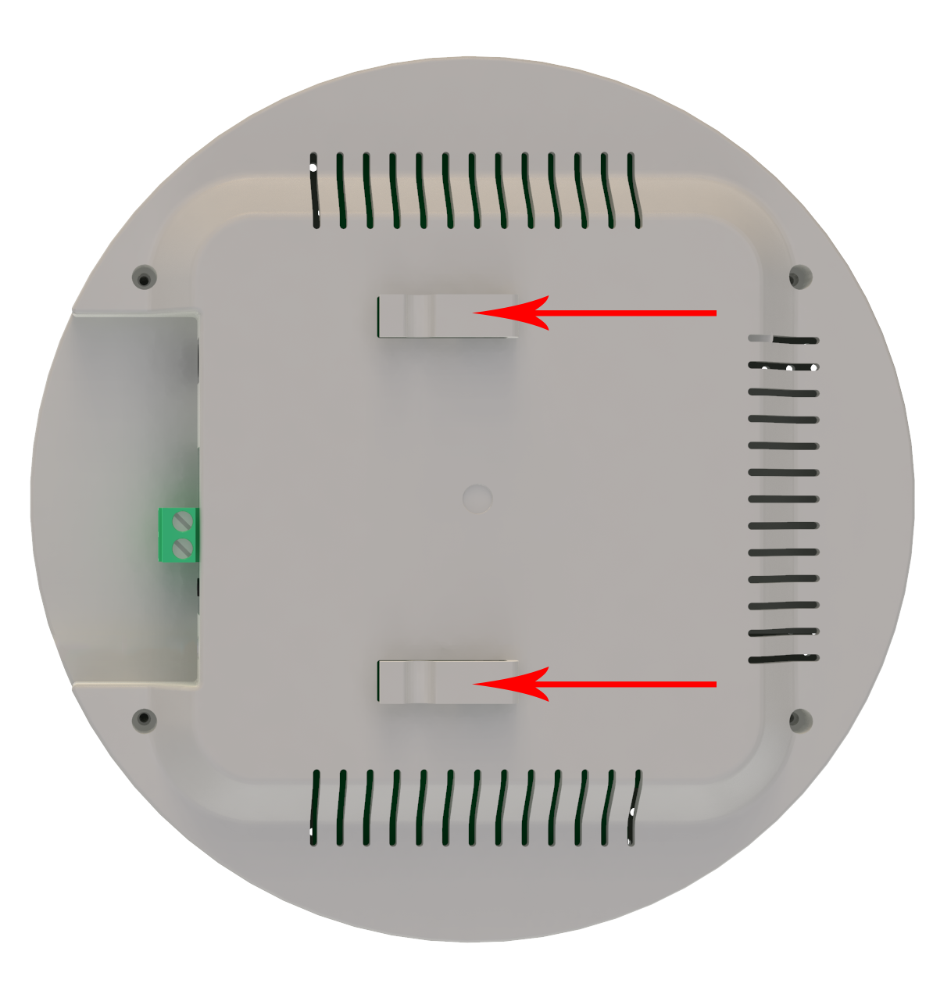

## 3.3Examples of installation methods

**3.3.1Ceiling installation**

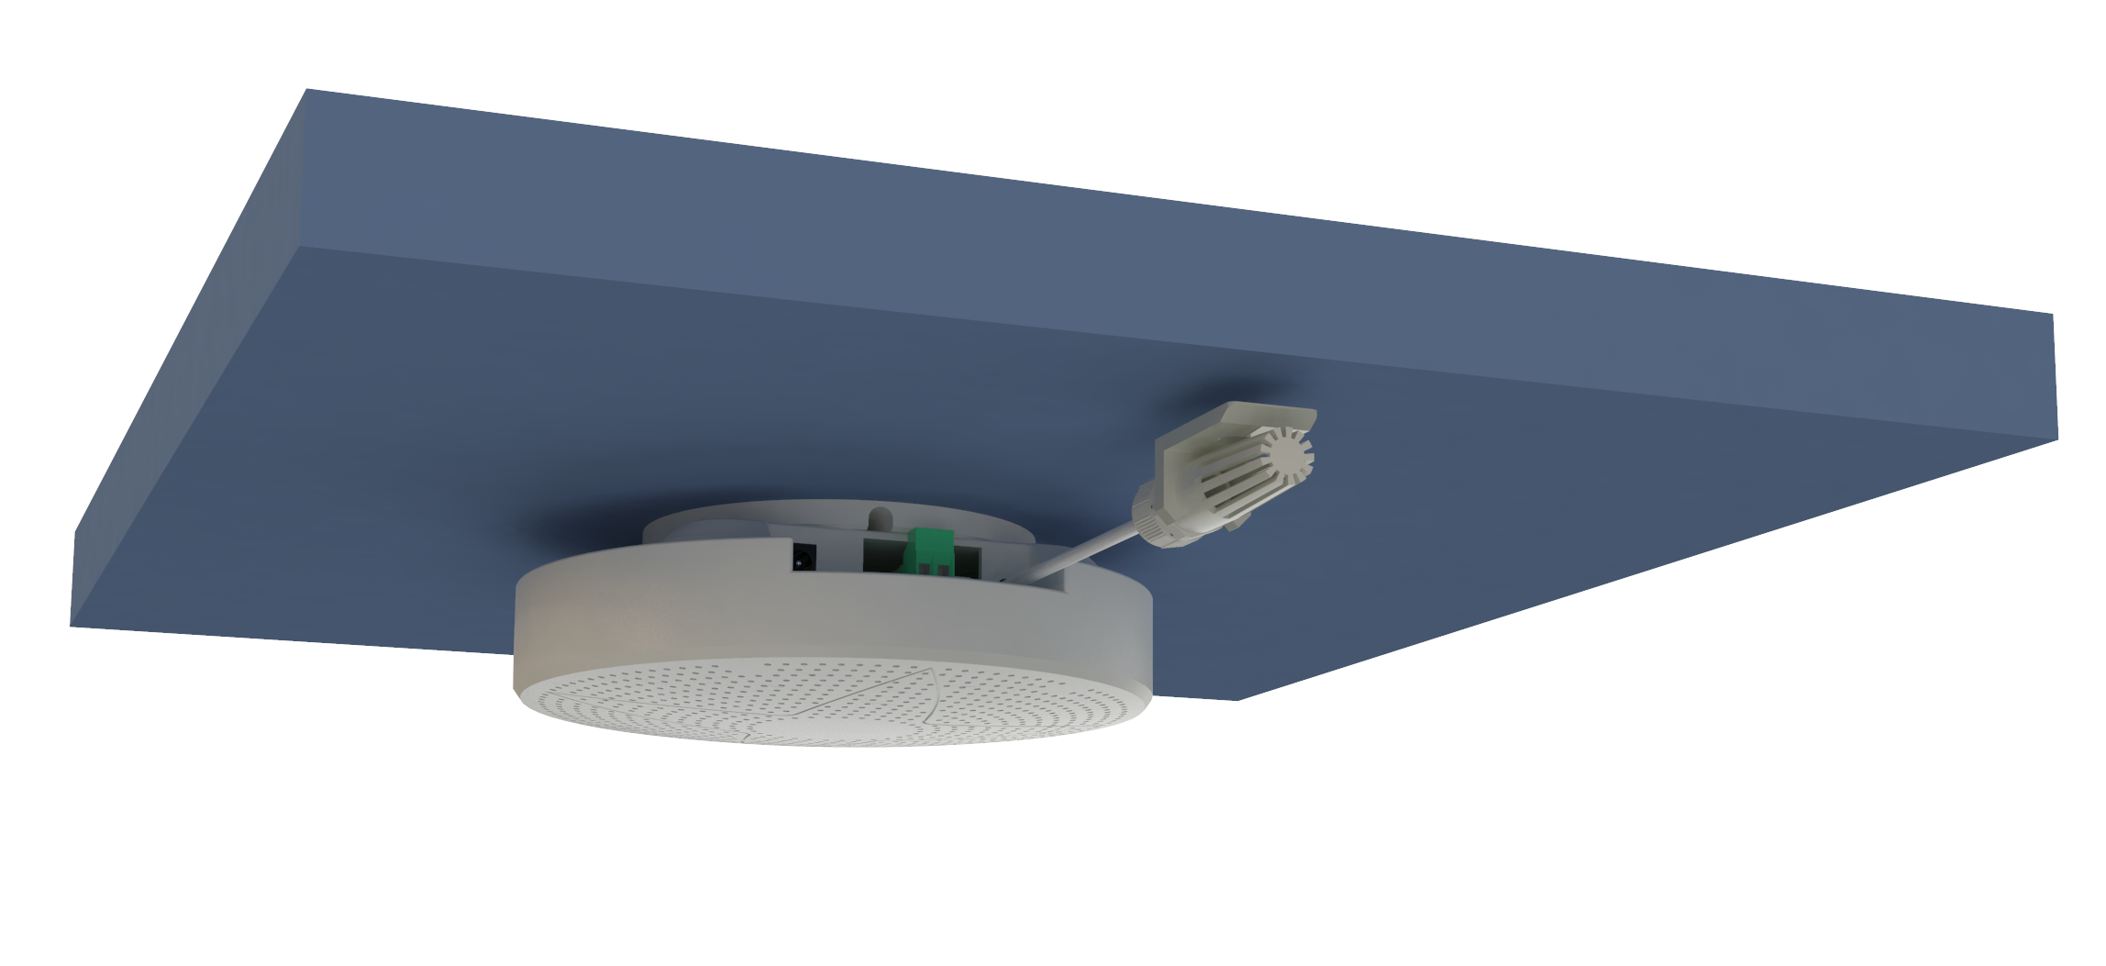

**3.3.2Wall-mounted installation**

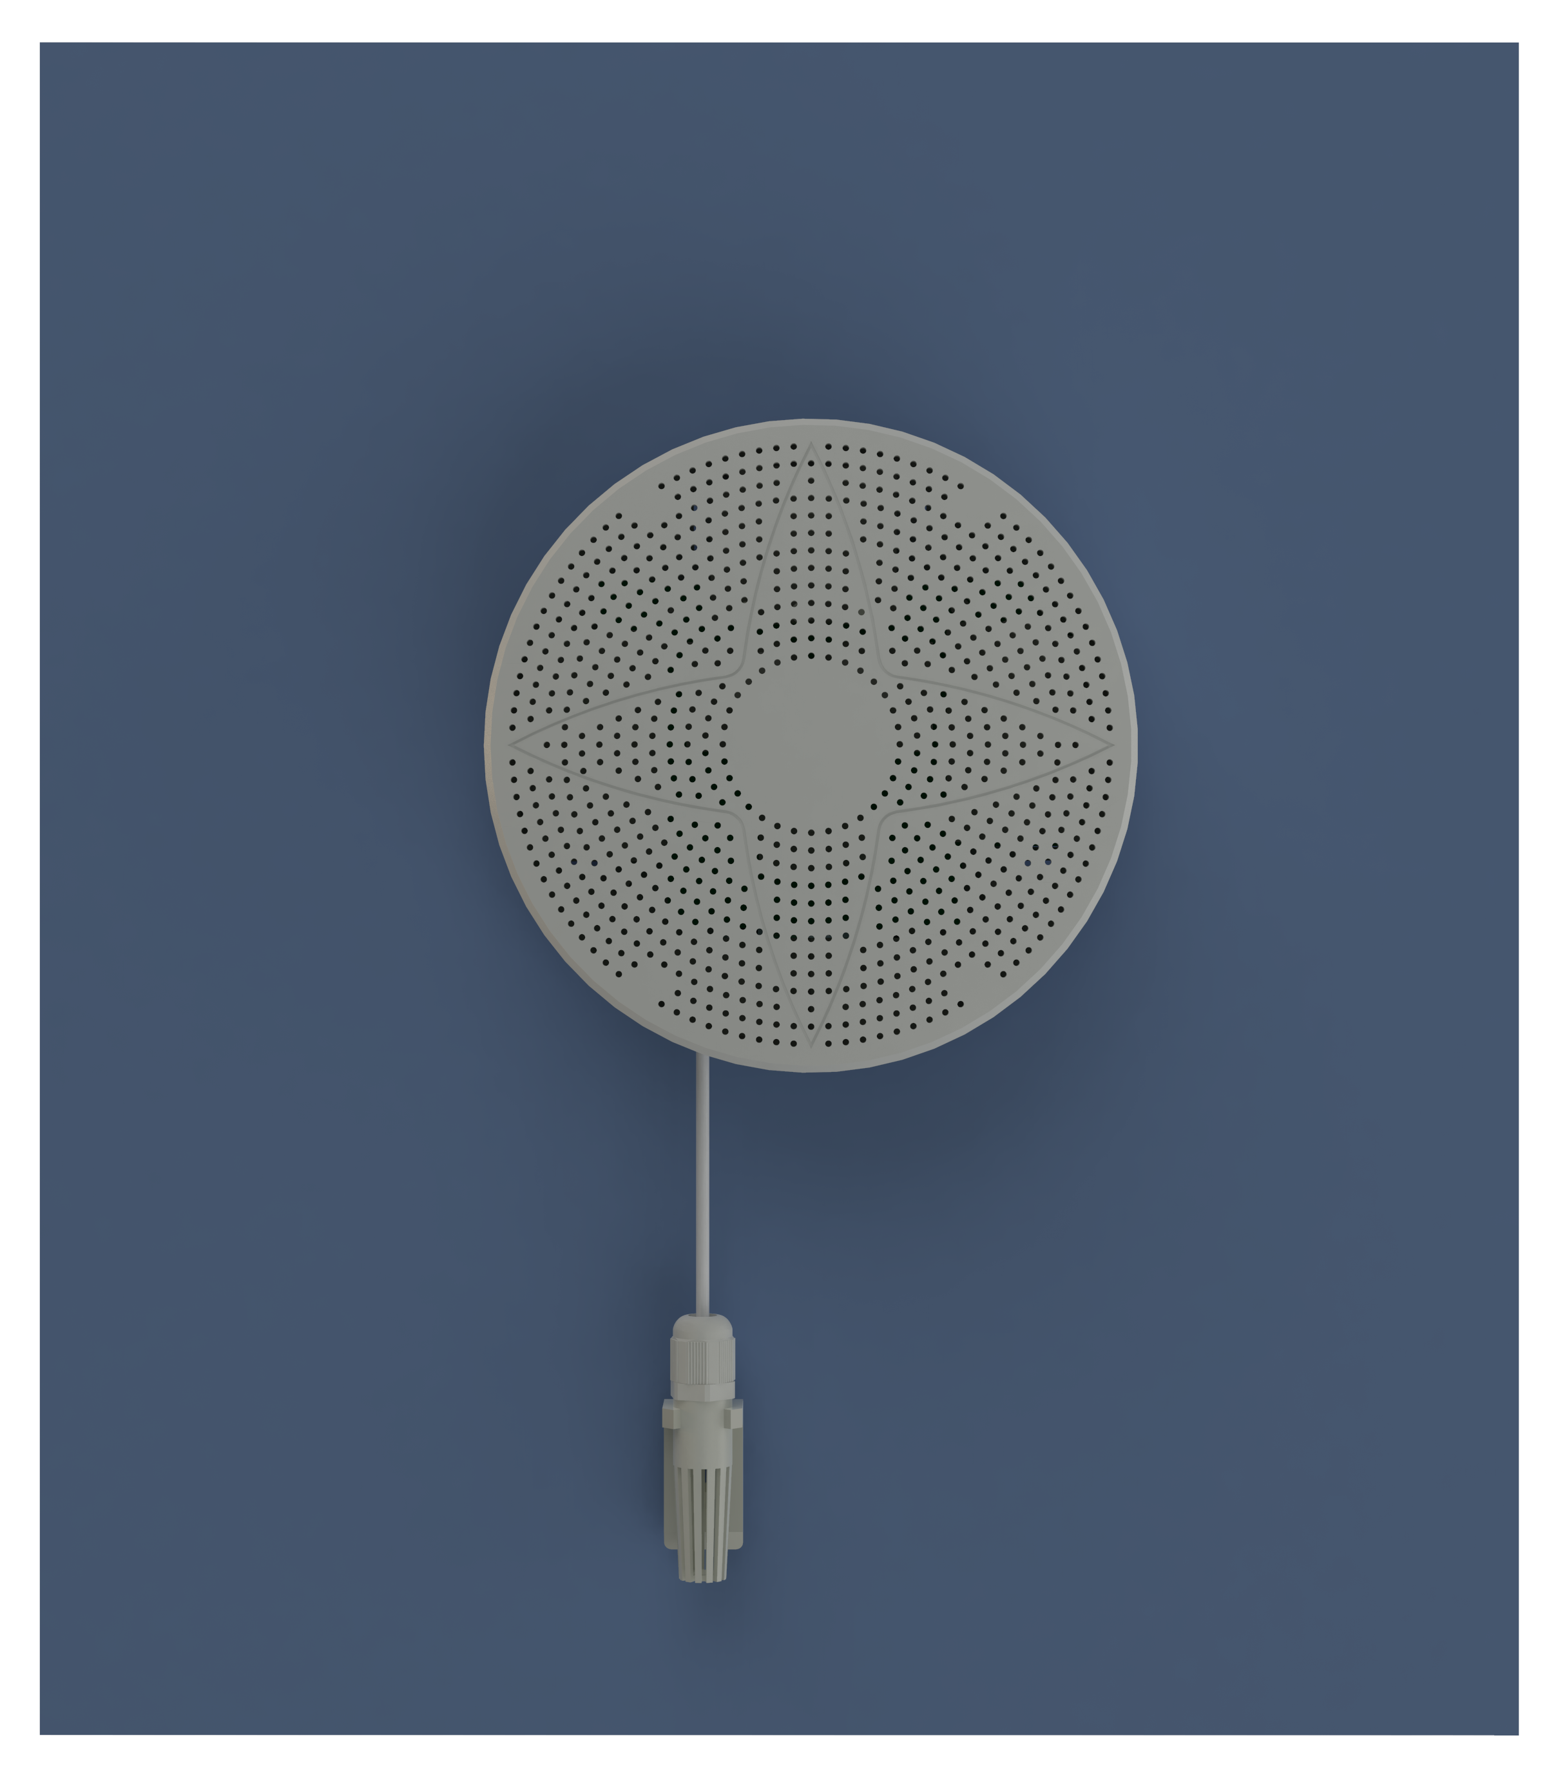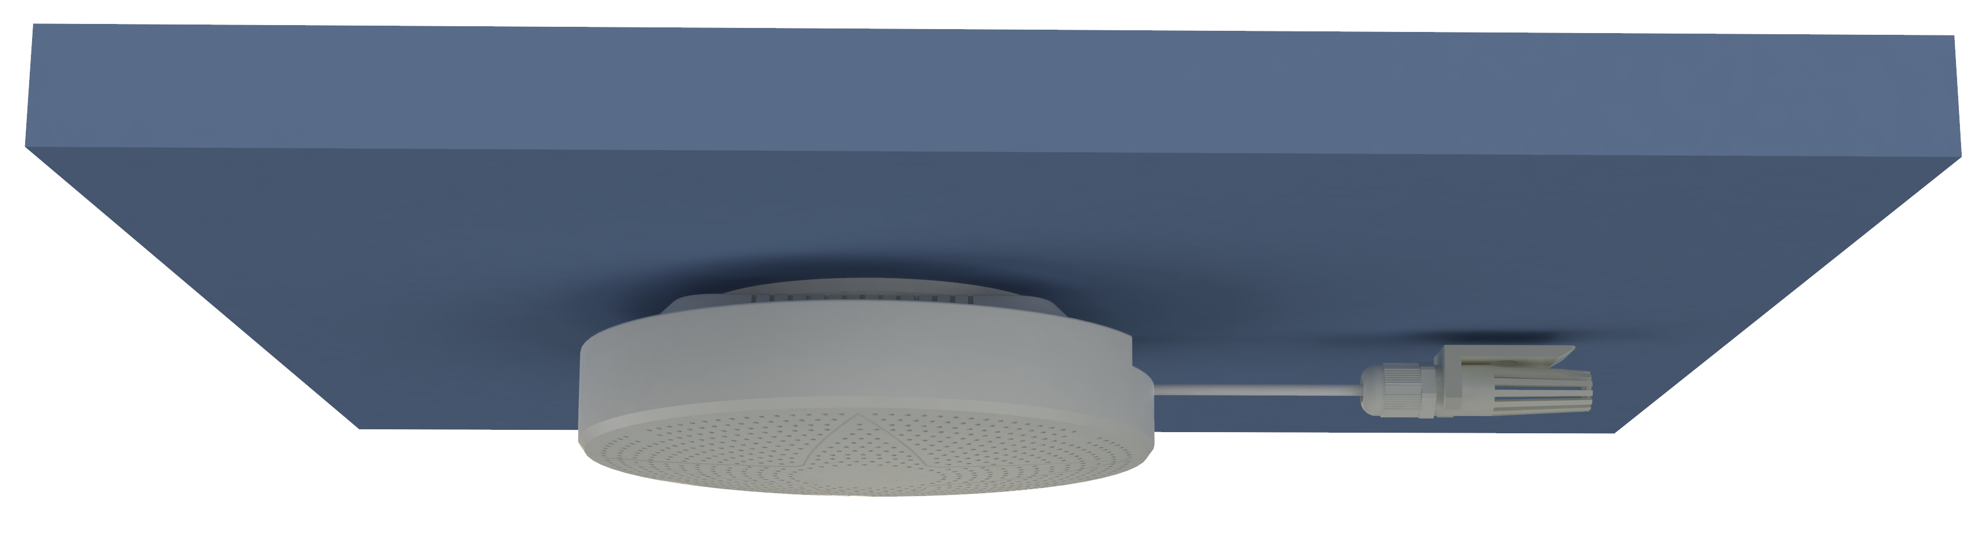

# 4.Interface Description

Wide voltage power input can be 10 ~ 30V. When connecting the 485 signal line, please note that the two lines A and B cannot be reversed, and the addresses of multiple devices on the bus cannot conflict.

485B

485A

Power jack（10~30V DC）

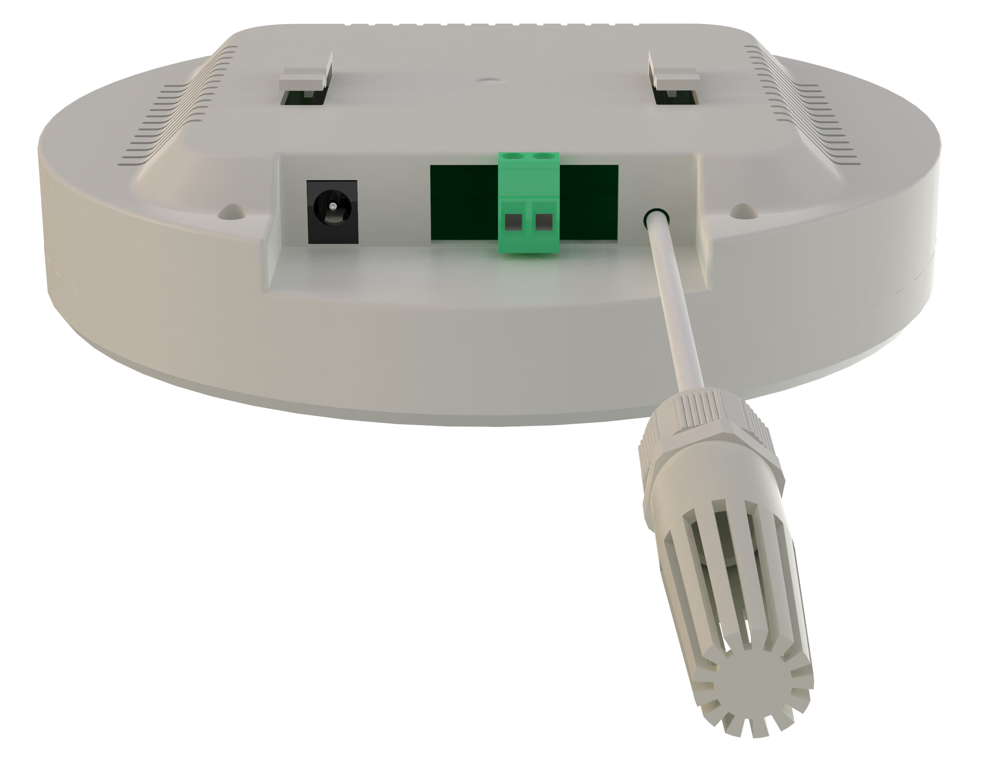

# 5.Configuration software installation and use

## 5.1Software selection

Open the data package, select "Debug software" --- "485 parameter configuration software", findJust open it.

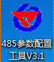

## 5.2parameter settings

①, select the correct COM port ("COM"-"Properties-Device Manager-Port" to view the COM port), the following figure lists the driver names of several different 485 converters.

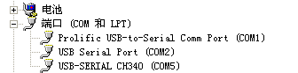

②, only connect one device and power on, click the test baud rate of the software, the software will test the current device baud rate and address, the default baud rate is 4800bit / s, the default address is 0x01.

③ Modify the address and baud rate according to the needs of use, and at the same time, you can query the current functional status of the device.

④ If the test is unsuccessful, please recheck the device wiring and 485 driver installation.

⑤ Click on the corresponding gas to directly view the current real-time value of the gas.

⑥ Note: This software can only set three baud rates of 2400bit / s, 4800bit / s and 9600bit / s.

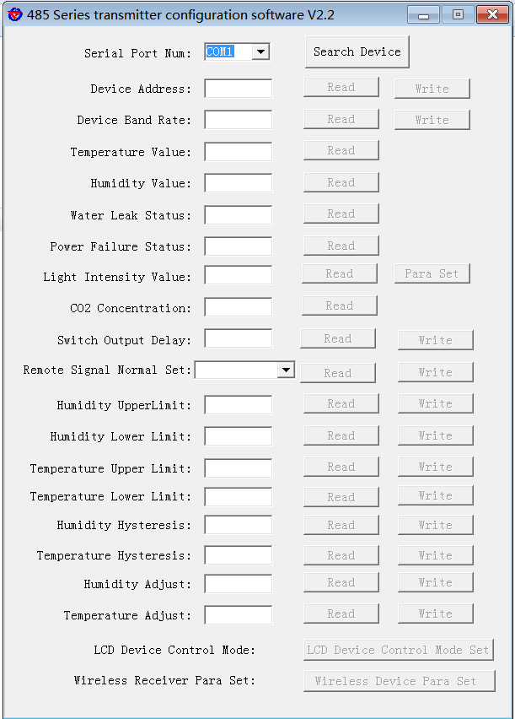

# 6.letter of agreement

## 6.1Communication basic parameters

|  |  |
| --- | --- |
| Coding | 8-bit binary |
| Data bit | 8 bit |
| Parity bit | no |
| Stop bit | 1 person |
| Error checking | CRC (Redundant Cyclic Code) |
| Baud rate | 2400bit / s, 4800bit / s, 9600bit / s, 19200bit / s can be set, the factory default is 4800bit / s |

## 6.2Data frame format definition

Using Modbus-RTU communication protocol, the format is as follows:

Time for initial structure ≥ 4 bytes

Address code = 1 byte

Function code = 1 byte

Data area = N bytes

Error check = 16-bit CRC code

End structure ≥ 4 bytes of time

Address code: the address of the transmitter, which is unique in the communication network (factory default 0x01).

Function code: the instruction function instruction issued by the host, this transmitter only uses the function code 0x03 (read register data).

Data area: The data area is specific communication data, pay attention to the high byte of 16bits data first!

CRC code: two-byte check code.

Host inquiry frame structure:

|  |  |  |  |  |  |
| --- | --- | --- | --- | --- | --- |
| address code | function code | Register start address | Register length | Check digit low | Check digit high |
| 1byte | 1byte | 2byte | 2byte | 1byte | 1byte |

Slave response frame structure:

|  |  |  |  |  |  |  |
| --- | --- | --- | --- | --- | --- | --- |
| address code | function code | Effective bytes | Data area | Data area two | Data N area | Check code |
| 1byte | 1byte | 1byte | 2byte | 2byte | 2byte | 2byte |

## 6.3Register address

|  |  |  |  |  |
| --- | --- | --- | --- | --- |
| Register address | PLC or configuration address | content | operating | Scope and definition |
| 0000 H | 40001 | PM2.5 (ug/m3) | Read only | Actual value |
| 0001 H | 40002 | PM10 (ug/m3) | Read only | Actual value |
| 0002 H | 40003 | temperature（℃） | Read only | 10 times more upload |
| 0003 H | 40004 | humidity (%RH) | Read only | 10 times more upload |
| 0004 H | 40005 | Atmospheric pressure (KPa) | Read only | 10 times more upload |
| 0005 H | 40006 | Illumination (Lux) | Read only | High actual light value |
| 0006 H | 40007 | Low actual light value |
| 0007 H | 40008 | TVOC (ppb) | Read only | Actual value |
| 0008 H | 40009 | Co2 (ppm) | Read only | Actual value |
| 0009 H | 40010 | CH₂O (ppm) | Read only | 100 times more upload |
| 000A H | 40011 | O3 (ppm) | Read only | 100 times more upload |
| 000B H | 40012 | O (%Vol) | Read only | 100 times more upload |
| 000C H | 40013 | H2S(ppm) | Read only | Actual value |
| 000D H | 40014 | CH4 (%LEL) | Read only | Actual value |
| 000E H | 40015 | CO (ppm) | Read only | Actual value |
| 000F H | 40016 | NO2 (ppm) | Read only | 10 times more upload |
| 0010 H | 40017 | SO2 (ppm) | Read only | 10 times more upload |
| 0011 H | 40018 | H2 (ppm) | Read only | Actual value |
| 0012 H | 40019 | NH3 (ppm) | Read only | Actual value |
| 0050 H | 40081 | PM2.5 Calibration value | Read and write | Actual value |
| 0051 H | 40082 | PM10 Calibration value | Read and write | Actual value |
| 0052 H | 40083 | Temperature calibration value | Read and write | 10 times more upload |
| 0053 H | 40084 | Humidity calibration value | Read and write | 10 times more upload |
| 0054 H | 40085 | Atmospheric pressure calibration value | Read and write | 10 times more upload |
| 0056 H | 40087 | Illumination calibration value | Read and write | Actual value |
| 0057 H | 40088 | TVOC calibration value | Read and write | Actual value |
| 0058 H | 40089 | CO2 calibration value | Read and write | Actual value |
| 0059 H | 40090 | Formaldehyde calibration value | Read and write | 100 times more upload |
| 005A H | 40091 | Ozone calibration value | Read and write | 100 times more upload |
| 005B H | 40092 | Oxygen calibration value | Read and write | 10 times more upload |
| 005C H | 40093 | Hydrogen sulfide calibration value | Read and write | Actual value |
| 005D H | 40094 | Methane calibration value | Read and write | Actual value |
| 005E H | 40095 | Carbon monoxide calibration value | Read and write | Actual value |
| 005F H | 40096 | Nitrogen dioxide calibration value | Read and write | 10 times more upload |
| 0060 H | 40097 | Calibration value of sulfur dioxide | Read and write | 10 times more upload |
| 0061 H | 40098 | Hydrogen calibration value | Read and write | Actual value |
| 0062 H | 40099 | Ammonia calibration value | Read and write | Actual value |
| 07D0 H | 42001 | 485 address | Read and write | 1 ~ 255 (factory default 1) |
| 07D1 H | 42002 | 485 baud rate | Read and write | 0 means 2400bit / s  1 for 4800bit / s  2 for 9600bit / s |

## 6.4Communication protocol example and explanation

**6.4.1Read the PM2.5 real-time value (actual value) of device address 0x01**

Inquiry frame

|  |  |  |  |  |  |
| --- | --- | --- | --- | --- | --- |
| **address code** | **function code** | **starting address** | **Data length** | **Check digit low** | **Check digit high** |
| 0x01 | 0x03 | 0x00 0x00 | 0x00 0x01 | 0x84 | 0x0A |

Reply frame

|  |  |  |  |  |  |
| --- | --- | --- | --- | --- | --- |
| **address code** | **function code** | **Returns the number of valid bytes** | PM2.5**value** | **Check digit low** | **Check digit high** |
| 0x01 | 0x03 | 0x02 | 0x00 0x12 | 0x38 | 0x49 |

PM2.5:

0012 H (hexadecimal) = 18 => PM2.5 = 18 ug / m3

**6.4.2 Read the real-time value of SO2 (20ppm) at device address 0x01 (upload 10 times larger)**

Inquiry frame

|  |  |  |  |  |  |
| --- | --- | --- | --- | --- | --- |
| **address code** | **function code** | **starting address** | **Data length** | **Check digit low** | **Check digit high** |
| 0x01 | 0x03 | 0x00 0x10 | 0x00 0x01 | 0x85 | 0xCF |

Reply frame

|  |  |  |  |  |  |
| --- | --- | --- | --- | --- | --- |
| **address code** | **function code** | **Returns the number of valid bytes** | SO2 **value** | **Check digit low** | **Check digit high** |
| 0x01 | 0x03 | 0x02 | 0x00 0x64 | 0xB9 | 0xAF |

SO2：

0064 H(Hex) =100 => SO2=10ppm

**6.4.3SO2 calibration value written to device address 0x01 (enlarge 10 times to write)**

Inquiry frame

|  |  |  |  |  |  |
| --- | --- | --- | --- | --- | --- |
| **address code** | **function code** | **starting address** | **Write data area** | **Checksum low byte** | **Check code high byte** |
| 0x01 | 0x06 | 0x00 0x60 | 0x00 0x14 | 0x45 | 0xDB |

Reply frame

|  |  |  |  |  |  |
| --- | --- | --- | --- | --- | --- |
| **address code** | **function code** | **starting address** | **data input** | **Checksum low byte** | **Check code high byte** |
| 0x01 | 0x06 | 0x00 0x60 | 0x00 0x14 | 0x45 | 0xDB |

# Write SO2 calibration (set the calibration value to 2ppm):

# SO2 2ppm Expand ten times write = 20 => 0014 H (Hexadecimal)

# 7.Common problems and solutions

# Device cannot be connected to PLC or computer

# possible reason:

# 1) The computer has multiple COM ports, and the selected port is incorrect.

# 2) The device address is wrong, or there are devices with duplicate addresses (the factory default is all 1).

# 3) Baud rate, check mode, data bit, stop bit error.

# 4) The host's polling interval and waiting time for answering are too short, and both need to be set above 200ms.

# 5) The 485 bus is disconnected, or the A and B lines are reversed.

# 6) If the number of devices is too large or the wiring is too long, power should be supplied nearby, and a 485 booster should be added, and 120Ω terminal resistance should be added at the same time.

# 7) The USB to 485 driver is not installed or damaged.

# 8) The equipment is damaged.

# 8.contact details

# Shandong Renke Control Technology Co., Ltd.

# Address: No. 2886 Fengqi Road, High-tech Zone, Jinan City, Shandong Province

# Postcode: 250101

# Phone: 400-085-5807

# Fax: (86) 0531-67805165

# Website: www.renke.com

# Cloud platform address: [www.0531yun.cn](http://www.0531yun.cn)



# 9.Document history

V1.0 document creation